You are given an m x n binary matrix grid. An island is a group of 1's (representing land) connected **4-directionally** (horizontal or vertical.) You may assume all four edges of the grid are surrounded by water.

The **area** of an island is the number of cells with a value 1 in the island.

Return *the maximum* ***area*** *of an island in* grid. If there is no island, return 0.

**Example 1:**

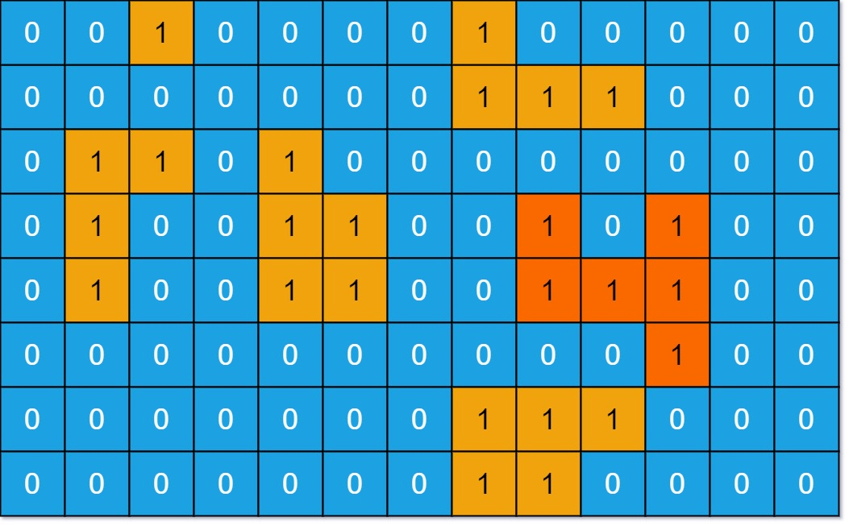

Input: grid = [[0,0,1,0,0,0,0,1,0,0,0,0,0],[0,0,0,0,0,0,0,1,1,1,0,0,0],[0,1,1,0,1,0,0,0,0,0,0,0,0],[0,1,0,0,1,1,0,0,1,0,1,0,0],[0,1,0,0,1,1,0,0,1,1,1,0,0],[0,0,0,0,0,0,0,0,0,0,1,0,0],[0,0,0,0,0,0,0,1,1,1,0,0,0],[0,0,0,0,0,0,0,1,1,0,0,0,0]]  
Output: 6  
Explanation: The answer is not 11, because the island must be connected 4-directionally.

**Example 2:**

Input: grid = [[0,0,0,0,0,0,0,0]]  
Output: 0

**Constraints:**

* m == grid.length
* n == grid[i].length
* 1 <= m, n <= 50
* grid[i][j] is either 0 or 1.